Oleksandr Yardas
Tut-101-15
Paul Hutchison
11/30/2016
Exhibition draft

Calvin and Hobbes was a daily syndicated comic strip that ran from 1985-1995. Most of the strips are one-offs that have no narrative connection to each other, but sometimes Watterson would make multi-strip stories, ranging from from 2 strips in length to a whole months worth. Like the Sunday strips, they depart from the regular 4-panel format, but whereas the Sunday strips are a result of Watterson playing with the form and flow of the comic, these multi strip stories are Watterson playing with his world, showing stories and ideas that are seldom thought about in the context of Calvin and Hobbes.

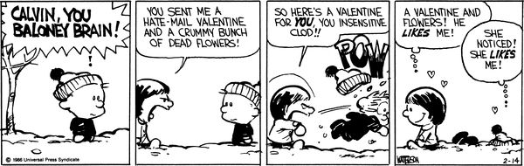
The Tales of Calvin and Hobbes
Figure 1: Feb 14 1986, from “Valentine” Feb 12-14 1986
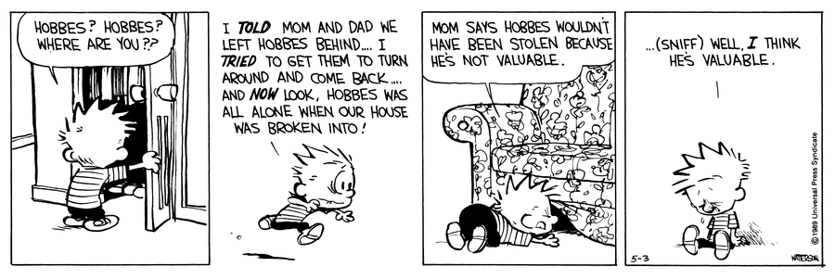
Figure 2: May 3 1989, from “Robbery” April 23-May 13 1989
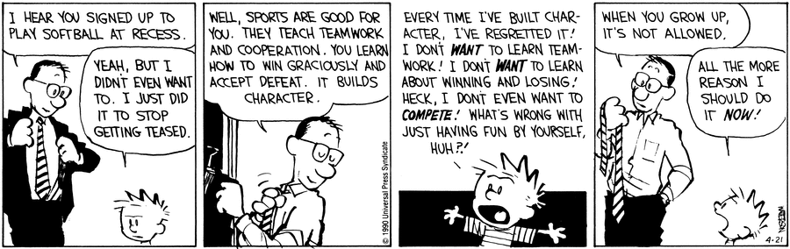
Figure 3: April 21 1990, from “Baseball” April 16-May 5 1990

Label:
There are around 200 stories in the 10 year run of the strip. Things like fear, love, and grief are all topics covered, but they are put in the context of characters that we are very familiar with yet who we rarely see exposed emotionally. Take some time to read the strips and reflect.

The other stuff:

I tried to make my process as straightforward as possible: I’d read all of the multi-strip stories and find a common theme and try to pick 4 or 5 strips that I felt best exemplified the variety. For example, I read a strip where Calvin is performing in a school play about nutrition and he plays an onion. His mom makes him the onion suit and he tries it on (it looks ridiculous). All the while he is having a lot of trouble memorizing his lines. Then the story skips to the night of the performance and right before he is supposed to go on stage, Calvin is nowhere to be found. He is stuck in the bathroom with his zipper jammed in his costume. While in this predicament he finally says his whole line, but it is no use because he can’t perform it. The play is cut short and the janitors have to go get him and get his zipper unstuck. Now I could write something like:
the thing that gave memorizing the line purpose, which was performing the line in the play is nullified because even though Calvin remembers his line, he is stuck in the bathroom and cannot perform. This is symbolic of the feeling of being stuck fighting the syndicate over licensing. Watterson had worked so hard to get where he was – much like Calvin trying to memorize his line – and he made it to the top and now the purpose of him being a comic artist in the first place, self expression, is threatened by the pressure to license.

That is a very specific interpretation of a scene in a strip that is part of a story that is almost a month’s worth of strips. Trying to analyze every single detail would be incredibly difficult to write and even more incredibly boring for an audience to read. The example I gave is also inaccurate as that story was written in the mid to late 80’s, in the days before the strip became popular and before the syndicate started pushing for licensing. So I tried to remember what a teacher of mine had said to me long ago: “You are not supposed to make sense of art, you are supposed to react to it!” Doing a total academic analysis panel by panel of multiple strips and relating them back to one another would be quite impressive, but unimaginably boring. There would be no reaction, no emotion; I would be putting an amount of effort into something that would not be reciprocated in any worthy form. So I decided that I would just read the comics like I would if I was doing it for fun. I only read about half of all the multi- strip stories, however I plan to try and read all of them by the time that you, dear reader (AKA Paul), receive this paper (at the latest 16:59:59 CST 12/1/2016). What I found through reading and reacting, being careful to record my reactions but not go so far as to start analyzing, was that I could empathize (or at least sympathize) with the characters and events that occur in these multi-strip stories. Some of them were sillier than others, like one where Calvin leaves class and changes into his Stupendous Man outfit, but silliness does not equate to a lack of relatability.
The strips I put in this draft are meant to sample of the variety of different topics explored in these stories, silly or otherwise. I am trying to get the reader to see how the strips make them feel. In Fig. 1, the theme is about love and its complexities. In Fig. 2 the theme is fear and longing, while in Fig. 3 the theme is questioning social norms. For my actual exhibition, I would like to include much more that 3 strips as while each story is self contained within itself, the goal of an emotional reaction is no likely to occur with only a few of them. Variety is the key.
By reading a multiple continuous narratives with different topics, a reader can form better understanding of the characters in Calvin and Hobbes. These are characters that they know well, but usually only ever see them in short segments. By making a reader gets to see how the characters react over a continuous stretch of time, they get a sense for their character and personality and see sides of them that they are usually oblivious to. Emotions can be attached to characters who have a strong enough realism, and this combined with the nostalgic yet simplistic style of the comic can aid in self reflection by stirring memories of ones past. I think it will be a good exhibition.

